Lab 4: ROM-based Game Access Control on FPGA

Stefan Bucur 3153

ECE5440

Contents

**1.** Introduction 3

**2.** System Architecture and Design 4

2.A: Button Shaper (bshaper) 4

2.B: Load Register (loadreg) 5

2.C: Access Control (access) 6

2.D: Addition (adder) 8

2.E: 4-to-7 Decoder (decoder7) 8

2.F: Check Module (check) 8

2.G: Digit Timer 9

2.H: Random Number Generator 10

**3.** Simulations 10

3.A: Button Shaper (bshaper) 10

3.B: Load Register (loadreg) 11

3.C: Access Control (access) 11

3.D: Addition (adder) 12

3.E: 4-to-7 Decoder (decoder7) 13

3.F: Check Module (check) 13

3.G: Digit Timer 13

3.H: Random Number Generator 14

**4.** FPGA Board Testing results 14

**5.** Conclusion 20

**5.** References 20

**I.** Appendix 20

# **1.** Introduction

Lab 4 is a math memorization game that tests a person’s ability to add and convert between binary, decimal and hexadecimal in their minds. The digital logic described in this design was made for the Altera DE2-115 prototyping board. The development in this lab focuses on implementing a login system to the game and a more robust player input system. When the device is first powered on, the number displays and indication lights are visible, but the player(s) cannot immediately begin playing the game; they must first enter the correct sequence of four-bit numbers one by one into the login system. Once the correct sequence is read, the system will indicate the game can be played and the player can begin entering numbers with their designated button and sets of switches.

Before starting, the game prompts the player to set a time limit into the two-digit timer. Once the number is set, pressing the access control button starts the game. The player generates a random number by pressing a button for the generator to change its value. In order to win, the player must enter the correct matching number into their 4 switches. If the two numbers add to 0xF (15 in decimal), the FPGA will change the indicator LEDs to verify the correct result. The player can try to match as many numbers from the computer player as possible before time runs out. The player is responsible for keeping score by their own means. If the players would like to leave the board for any reason and not want others to play, they can reset the board to log out and erase any previous work. At any point during operation the reset button can be pressed, reverting the system back to its initial state as if it were powered on for the first time.

Lab 4 modifies the access control module of Lab 3 by utilizing a ROM module to store the login password instead of hardcoding it into the module.

# **2.** System Architecture and Design

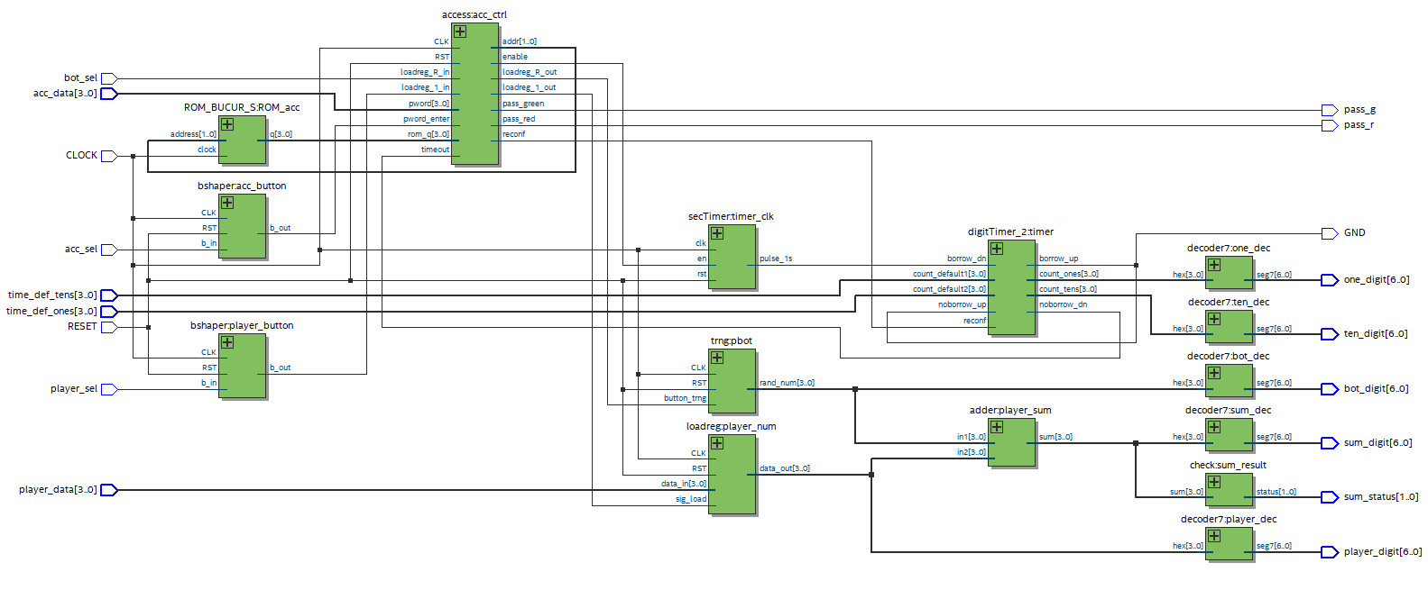

Figure : FPGA system architecture for Lab 4.

The FPGA’s sequential logic modules use the DE2-115’s 50MHz internal clock signal to update on its rising edge signal. Apart from RESET and the RNG generator button, the other two input button signals are first passed through their own button shaper module. This is due to the internal state machines of both the Access Control and Load Register modules treating a button activation signal as a new button press upon each new clock cycle. In order to reduce the complexity of the state machine, the button shaper converts the button’s debounced active low signal into a positive logic pulse that lasts one clock cycle. RESET is not shaped because the sequential logic modules should ideally be subject to multiple subsequent reset actions to ensure the entire system is set to the same initial state upon releasing the reset button. The acc_state wires within the FPGA are left for debugging purposes in simulations. Explained further below is a detailed explanation of the functionality of each of the modules in Figure 1.

## 2.A: Button Shaper (bshaper)

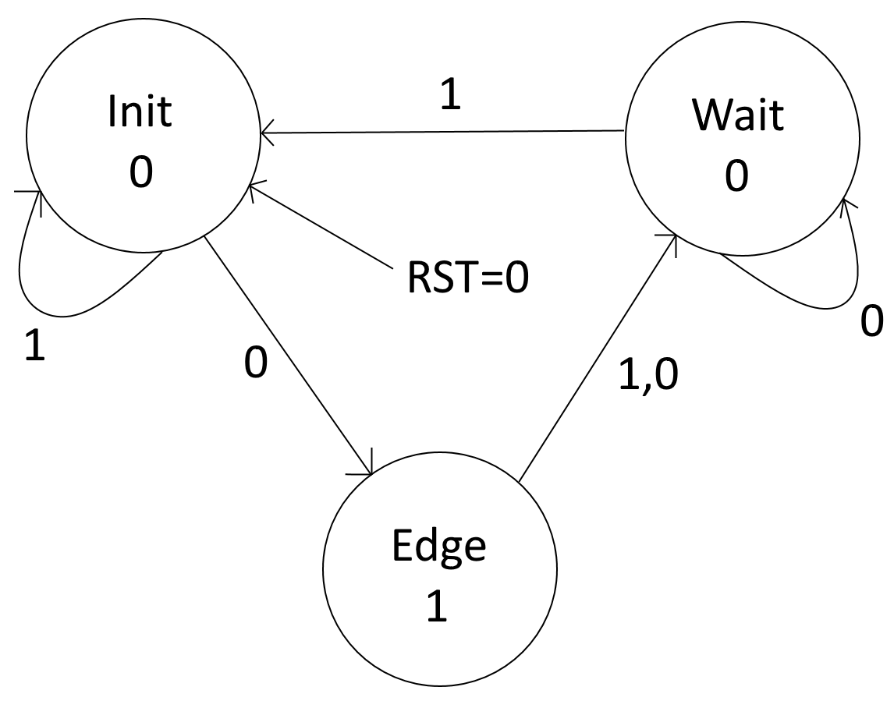

Figure : Finite state machine (FSM) for the button shaper. State values correspond to the button_out signal. Transition arrow values correspond to the button_in signal. RST = 1 does not affect the FSM and is therefore omitted.

The purpose of using the button shaper is to convert button inputs into signal events that are easier to process in sequential logic. By making the button press last one clock cycle at the start, the modules connected at the button shaper’s output will trigger an event at the next clock cycle without triggering another erroneously at the next cycle.

The button shaper module is a two-procedure finite state machine that converts an active low input signal lasting multiple clock cycles and converts it into an active high square pulse lasting only one clock cycle. The Init state is the default state, where it waits for the button active signal to change at which point it will transition to the edge state within that clock cycle. At the edge state, the output signal is set high and the state machine transitions to a wait state. Here it waits for the input signal to revert to its inactive value at which point the button shaper returns to the Init state. If RST is active when the button is held down, the state machine will ignore any button input until the reset is deactivated.

## 2.B: Load Register (loadreg)

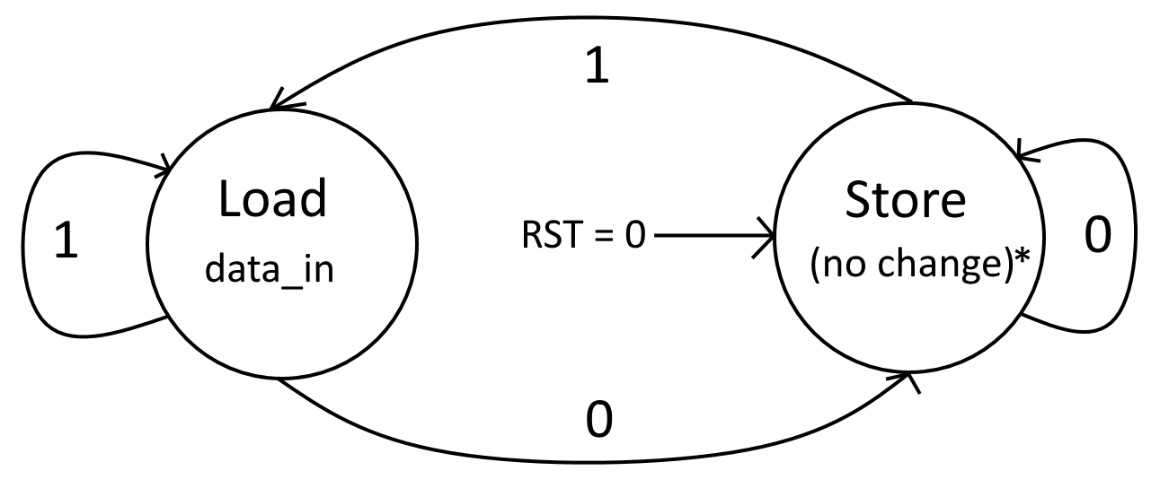

Figure : Finite state machine (FSM) for the load register module. State values correspond to the data_out signal. Transition arrow values correspond to the sig_load signal. RST = 1 does not affect the FSM and is therefore omitted.

The load register, while not being a requirement for proper operation, is implemented using a one-procedure finite state machine. There are only two states, where Store will keep the same output value unless it is reset, and upon receiving a high pulse from the button shaper will read from the player’s switch input (internally labelled data_in) in the Load state. Note in Figure 1 that sig_load is blocked by the access module and will only receive a signal if the access module passes it from the assigned button shaper as explained in section 2.C. Resetting the module with the RST signal will force the state machine to the Store state and overwrite the output to 0.

## 2.C: Access Control (access)

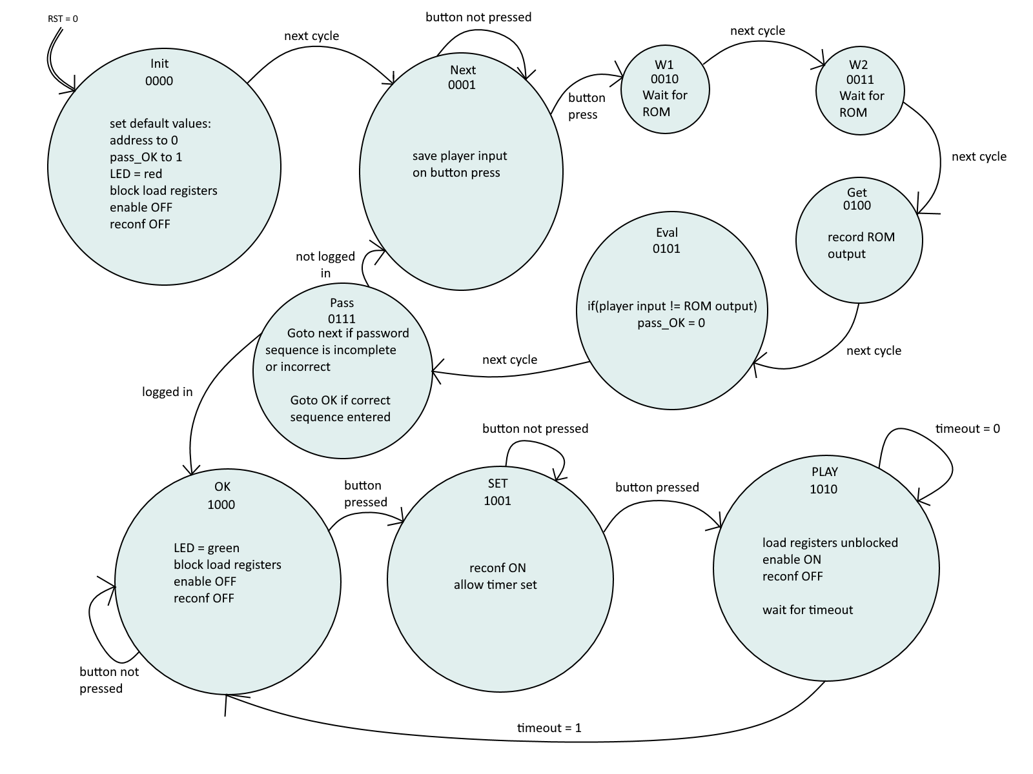

Figure : Finite state machine (FSM) for the access control module. RST = 0 forces the FSM to the Init state.

The access module is responsible for ensuring players can send button signals into the load registers only after the correct sequence is entered into the module via the pword 4-bit input and the pword_enter signal which is first passed through a button shaper. For this design, the sequence is **3 1 5 3**. The state names represent the number that the access module is asking for at that time. The 3-bit binary number at the bottom of each state is the numerical value corresponding to that state within the FSM and is stored as the variable currentstate. The module is configured to allow currentstate to be wired to an output pin, but for this design it is intentionally left out, as there already exists a pair of indicator lights (pass_r for a red LED and pass_g for green) that show when the player(s) are logged out (only red on) or logged in (only green on). The module still has it available as an output for either future use in other designs or debugging within simulations.

When pword_enter is 1, the access control saves the player input switch data internally. Next it waits two cycles for the ROM module to update its output to the address given by this module. The Get state records the output internally and the Eval state compares the result against the stored player input. If there is a mismatch, the pass_OK flag is set to 0 to indicate the player has entered the wrong sequence and should not log in once all 4 digits are entered. The Pass state decides when the address reaches the final digit if the user should go to the game states (OK) or back to the Next state to keep prompting the user to enter a number again. If the sequence is finished but not correct, pass_OK is reset before returning to Next.

The OK, SET, and PLAY states constitute the game loop. After pressing the button again into the SET state, the digit timers are in reconfiguration mode and the player can now enter the starting time for the two-digit timer using the 8 switches next to the 4 connected to the player’s load register. Note that the time is in BCD format. Pressing the button one last time will allow the digit timer to start counting down, enabling the 1-second pulse generator. When the timer reaches 0, it will send a timeout signal to the access control at which point it will return to the OK state.

When the system is logged out, the player button is blocked by forcing the output to be zero regardless of the player’s button shaper output. This prevents the load register from reading a positive input and changing its value. The bot player’s blocked output is inverted since the button signal is not shaped before entering the random number generator.

It is important to note that if an incorrect number is entered before Digit_4, the state machine does not return to Digit_1 and carries on asking for the next digit in the sequence. Meaning if the 2nd digit is incorrect and the player tries to enter the sequence again from its current state, the access module will not go to the OK state. The player can either press the KEY1 button until the module returns to the Digit_1 state or press the RESET button.

## 2.D: Addition (adder)

The system uses a 4-bit adder to sum up the two player numbers and output the result. In this system the in1 and in2 values are wired to the output of the load register modules and update as soon as one of the input signals change. The sum is wired to a seven-segment display decoder to present it to the user.

## 2.E: 4-to-7 Decoder (decoder7)

In order to display numerical values in a clear and readable manner on the DE2-115 board, the FPGA must first convert the number into a 7-bit value to output to one of the seven-segment displays available on the board. The decoder7 module converts a 4-bit value and interprets it as a hexadecimal digit and output the matching 7-bit value that displays the digit in standard hex format.

## 2.F: Check Module (check)

The system will turn on a red or green LED if the sum of the two player’s numbers is or is not 15, respectively. The check module takes the output of the sum module and checks if the output is equal to 0xF and turns on the proper LED upon receiving the sum value. status[0] is to be wired to a red LED and status[1] wired to a green LED.

## 2.G: Digit Timer

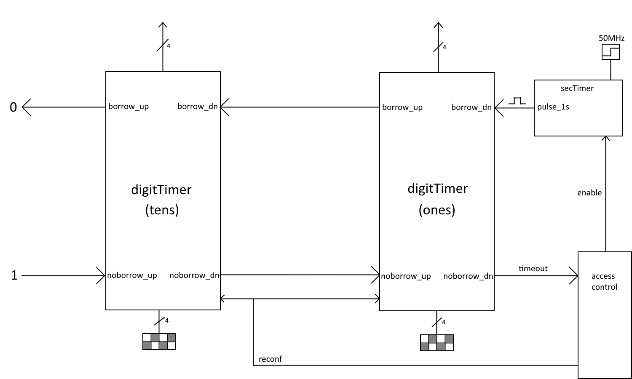

Figure : Two-digit timer architecture within the overall system. Module secTimer is driven by a 50MHz clock.

The timer is composed of two separate one-digit timers daisy-chained from a pulse generator creating a high pulse every 1 second for one clock cycle. When the access control module is in the SET state, the reconf bit is set high, allowing the built-in counter to be set to a starting value from the input switches. Once the access control goes to the PLAY state, the reconf bit is set low and enable bit is set high, starting the 1-second timer and signaling the digit timers to begin decrementing. Note that the reconf signal has priority over the enable, meaning the timer will not count down if reconf is set high.

When a digit timer receives a pulse from its borrow_dn input, the timer determines whether it can decrement its internal counter if it either holds a nonzero value or the noborrow_up signal is set low. If the timer has to borrow from an upper digit and is able to (noborrow_up is 0), the digit timer will set its borrow_up output to 1, acting as the upper digit’s borrow_dn pulse, telling it to decrement at the same time the lower digit sets to 9. If the counter is zero and is unable to borrow from the upper digit, it will set its noborrow_dn signal high to warn the lower digit that it cannot decrement further. The most significant digit has its borrow_up and noborrow_dn pins set to 0 and 1 respectively to ensure the digit does not try to borrow from nothing.

This timer behavior allows it to chain in series, where the noborrow_dn output of the least significant digit acting as a signal to notify an external module that all the timers have reached 0 and has therefore run out. The access control uses this signal to return to the OK state, lock the player inputs and disable the 1 second timer.

## 2.H: Random Number Generator

Acting as the heart of the bot player, the pseudorandom number generator take advantage of both the 50MHz clock rate and typical clock time a button is held down when pressed quickly by a human. Inside the number generator is a 4-bit counter that increments every clock cycle that the input button is held down. Since the top-level design does not have a button shaper in between the input button and this module, the active low signal from the button can persist for enough clock cycles such that when a person depresses the button it would be extremely difficult to determine exactly how many time the counter incremented, making it appear random.

The reason the generator is not truly random is due to the generation being dependent on factors that can be easily controlled such as manipulating the clock or sending artificial button signals. For the purpose of this game, this design is sufficient in giving the player a new number every button press to play against.

# **3.** Simulations

Described below are the system modules running within a custom simulation testbench module. Note that some modules are not tested for every possible value, however edge cases were carefully chosen to reflect real behavior and possible errors. All simulations of the system modules are done in Altera ModelSim.

## 3.A: Button Shaper (bshaper)

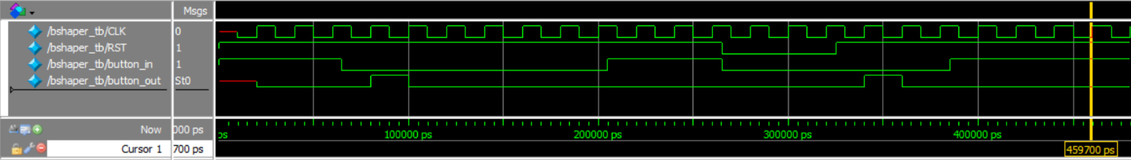

Figure : Simulation results for the button shaper testbench. First test produces a single pulse form a button input. Second test suppresses button input with the reset button.

Before the first clock cycle, the current state of the FSM is not known until the first clock cycle. The button shaper defaults to the Init state if no previous state exists or is undefined. The button shaper will output a one clock cycle wide high pulse at the output right after the first rising edge of the clock where the input equals 0. The input is held down, but the button shaper only produces the one pulse. The button is pressed down again, but the reset is held down for the first few clock cycles. When the reset is held down, the state machine is forced to stay in its Init state, preventing the module from producing a pulse wave until the first clock cycle where the reset is not held down. Again, only one square pulse is output for the entire duration of the button press.

## 3.B: Load Register (loadreg)

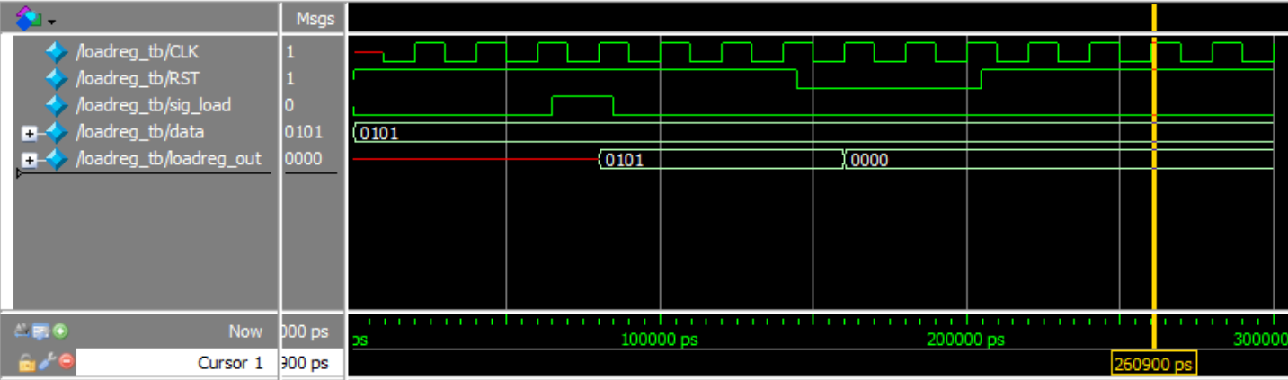

Figure : Simulation results for the load register testbench. The number 5 is loaded into the register after the load signal (sig_load) and is reset after pressing reset.

Before the first clock cycle, the current state of the FSM is not known until the first clock cycle. The load register defaults to the Store state if no previous state exists or is undefined. Because no previous data_out exists, the output is undefined until a value is successfully loaded in. Once sig_load receives a short pulse, the value 5 is loaded from the switches and into the register. Pressing the reset button will set the register to 0.

## 3.C: Access Control (access)

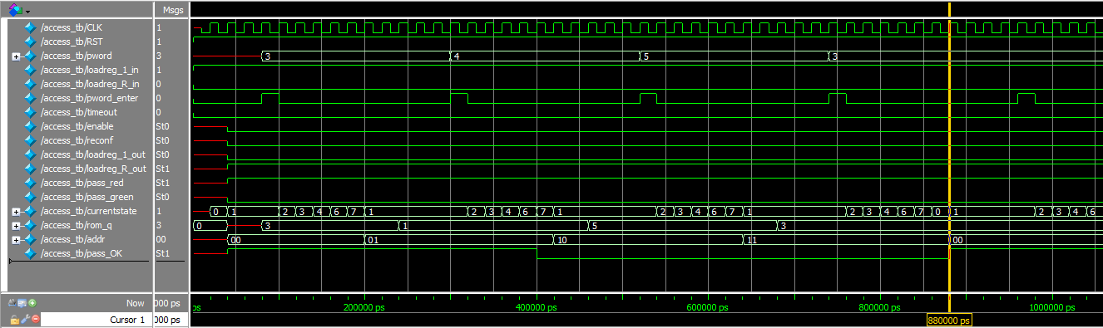

Figure a: Simulation of the access control testbench. User enters wrong password at second digit and fails the login sequence.

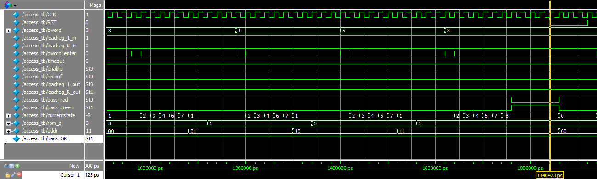

Figure 8b: Simulation of the access control testbench. User enters correct password before hitting reset.

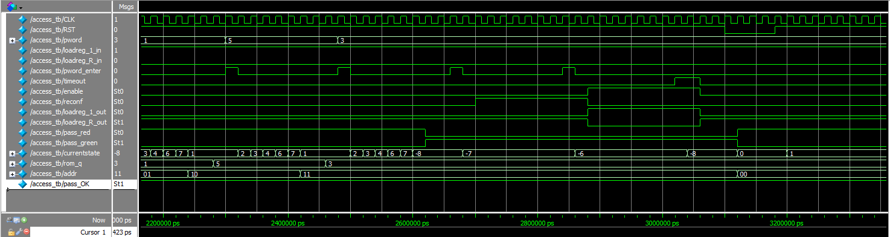

Figure 8c: Simulation of the access control testbench. User enters correct password and plays a round of the game.

The simulation shows the access control module correctly blocking inputs until the right sequence of 4 digits is entered for the password. Once logged in the game can be accessed, and the timer is reconfigurable before starting a round and enabling the countdown. Once a round starts it cannot be stopped unless the timer ends or the reset button is pressed (reset also logs the user out of the game.) Note that while the state machine has two empty states for waiting on the ROM to update, the ROM is ready well before the Get state. The wait states simply guarantee the ROM is ready on the chance that the state machine is modified further in the future.

## 3.D: Addition (adder)

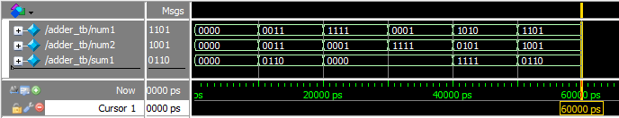Figure 9: Simulation of the adder testbench. Six different pairs of numbers were chosen to display the adder's behavior during normal and edge cases.

Since there are 256 possible input combinations for the adder, the testbench shows multiple example of normal and edge case behavior (in order): correctly adding to zero, correctly adding two numbers that can be displayed with four bits, addition overflow to 0, addition overflow with swapped values to show the commutative property of addition (A+B=B+A), two numbers that add to the ideal value of 15, and finally another overflow to a nonzero number. Note that there is no carry bit out for the adder, making it not ideal for chaining together to form larger adders. All values that do not add to 15 regardless of being able to be stored in 4 bits will count as a failure from the check module as intended; larger values simply overflow to 14 or lower.

## 3.E: 4-to-7 Decoder (decoder7)

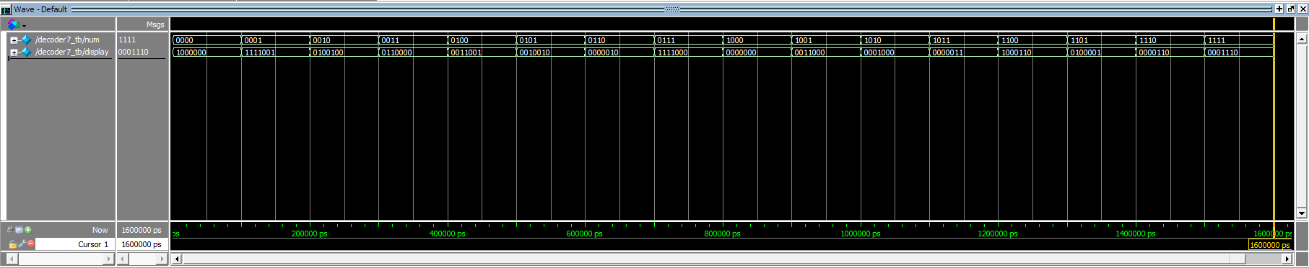

Figure 10: Simulation of the decoder7 testbench. All possible inputs are tested in order.

The DE2-115 manual states a specific pinout for the corresponding seven-segment lights for each display. More information can be found in the DE2-115 user manual in chapter 4.4[1]. Testing each of the possible 4-bit inputs yields the matching 7-bit sequence necessary to correctly light up the segment lines and display the 4-bit value as a hexadecimal digit.

## 3.F: Check Module (check)

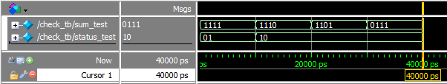

Figure : Simulation results for the check testbench. Testbench inputs the winning value of 15 followed by 3 losing numbers.

The check testbench only needs to check for two cases: winning (15) and losing (0 to 14). status_test[0] is on only for the losing values and status_test[1] is on only for the winning value of 15.

## 3.G: Digit Timer

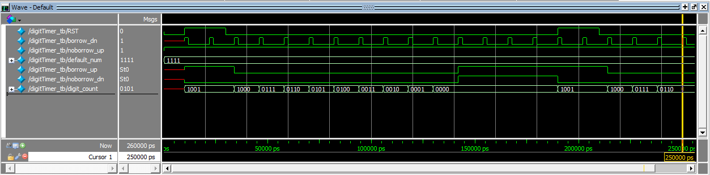

Figure 12: Simulation results for the one-digit timer. A value is preloaded, decremented to zero, and reset again.

Since the digit timer must read 4 bits but only hold and display decimal numbers, the digit timer must be able to handle values larger than 9. The timer will default to 9 in these cases. When the counter reaches zero, the next clock cycle shows the borrow_up and noborrow_dn signals set high. Resetting the timer sets these signals back to low, and the counter can begin counting down again.

## 3.H: Random Number Generator

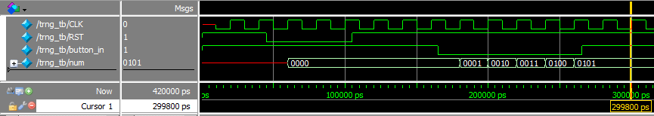

Figure 13: Random number generator is reset before sent a button signal. each new clock cycle, the counter is incremented.

Since the initial counter value is undefined at the start of the simulation, the module is first reset to a defined state. The counter begins at 0, but when the button signal is set low, it increments. every clock cycle. Letting go of the button (button_in = 1) holds the current value in the number generator. Physical use of this module would see the active low button signal last at least tens of thousands of clock cycles longer than what is shown, allowing the counter to arrive at an unpredictable value when used in the game.

# **4.** FPGA Board Testing results

This section details a general demonstration of the system working on a DE2-115 development board.

A video showing the login system can be found [here](https://drive.google.com/open?id=1Dgb2wPsvriyXv2quUo3ok2rFUY-RGxw4).

A video showing a short round of the game being played can be viewed [here](https://drive.google.com/open?id=1Df2QcTbtsue-P33lLRjVHGKuQvZfP2tk).

The following images explain the demonstration shown in the video as a reference.

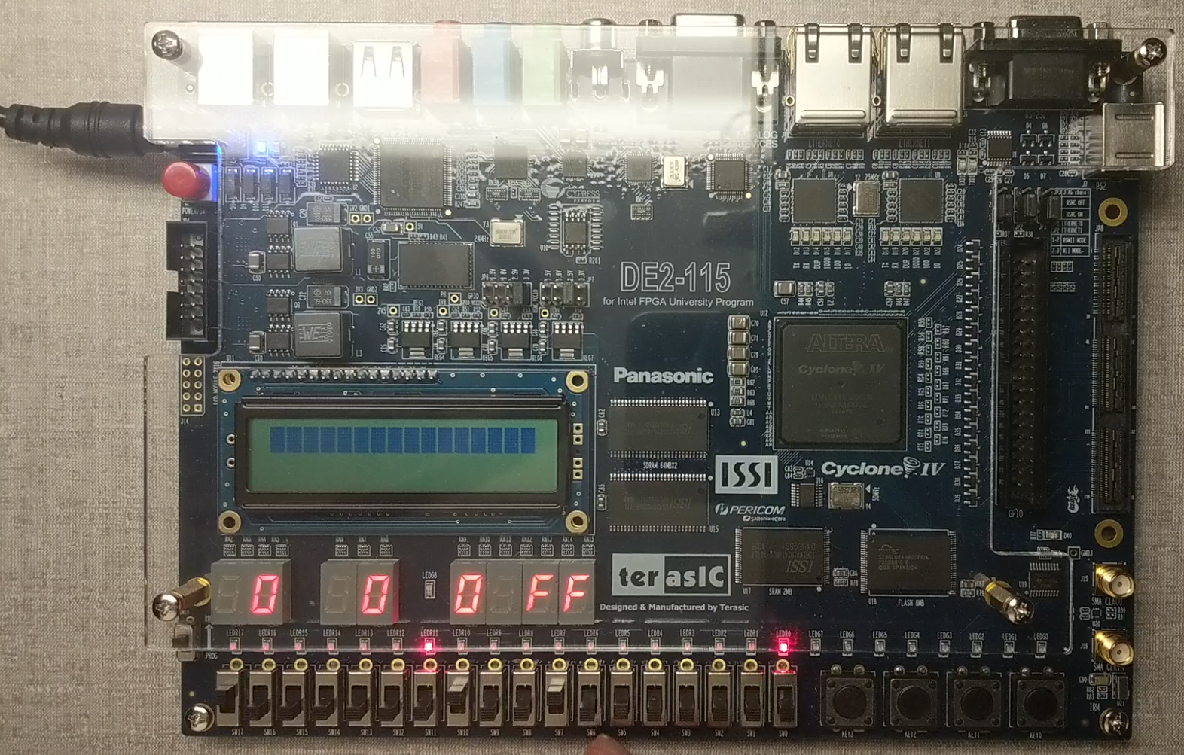

Figure 4: Initial board state. System is logged out.

The system is first powered on and the player register, random number generator, and digit timer are set to random values. This is expected and does not affect later use. The system is currently not logged in and requires the correct sequence (3153).

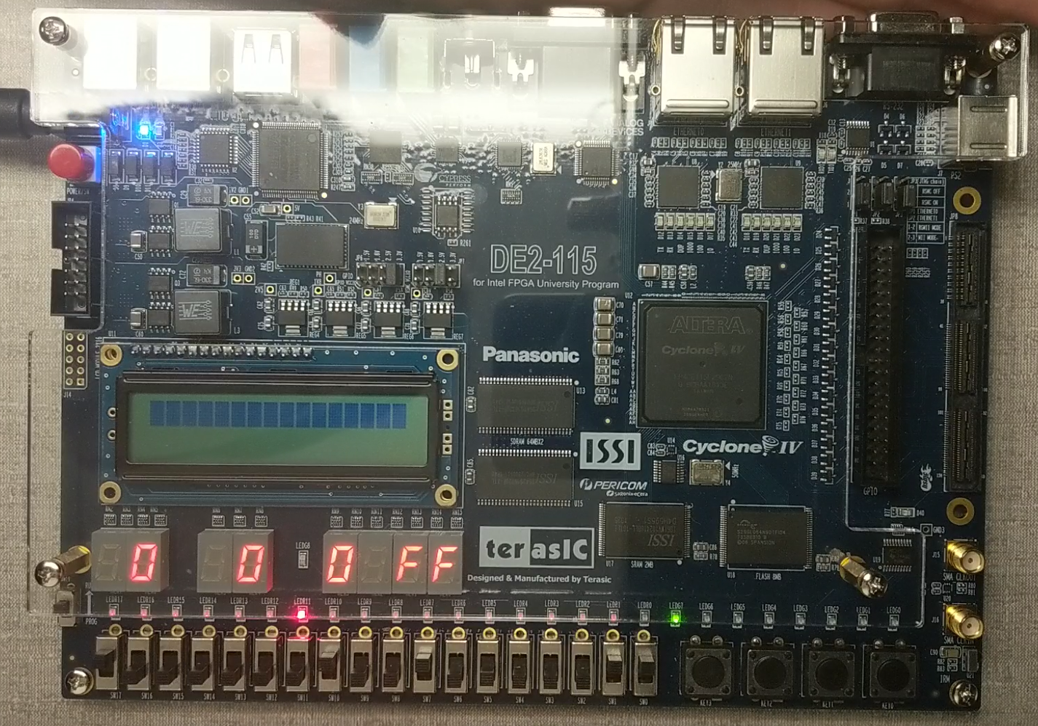

Figure 15: System is logged in.

Here the system is successfully logged in. Notice the red LED on the right is now off and the green LED is on, signaling the access control module has validated the correct sequence.

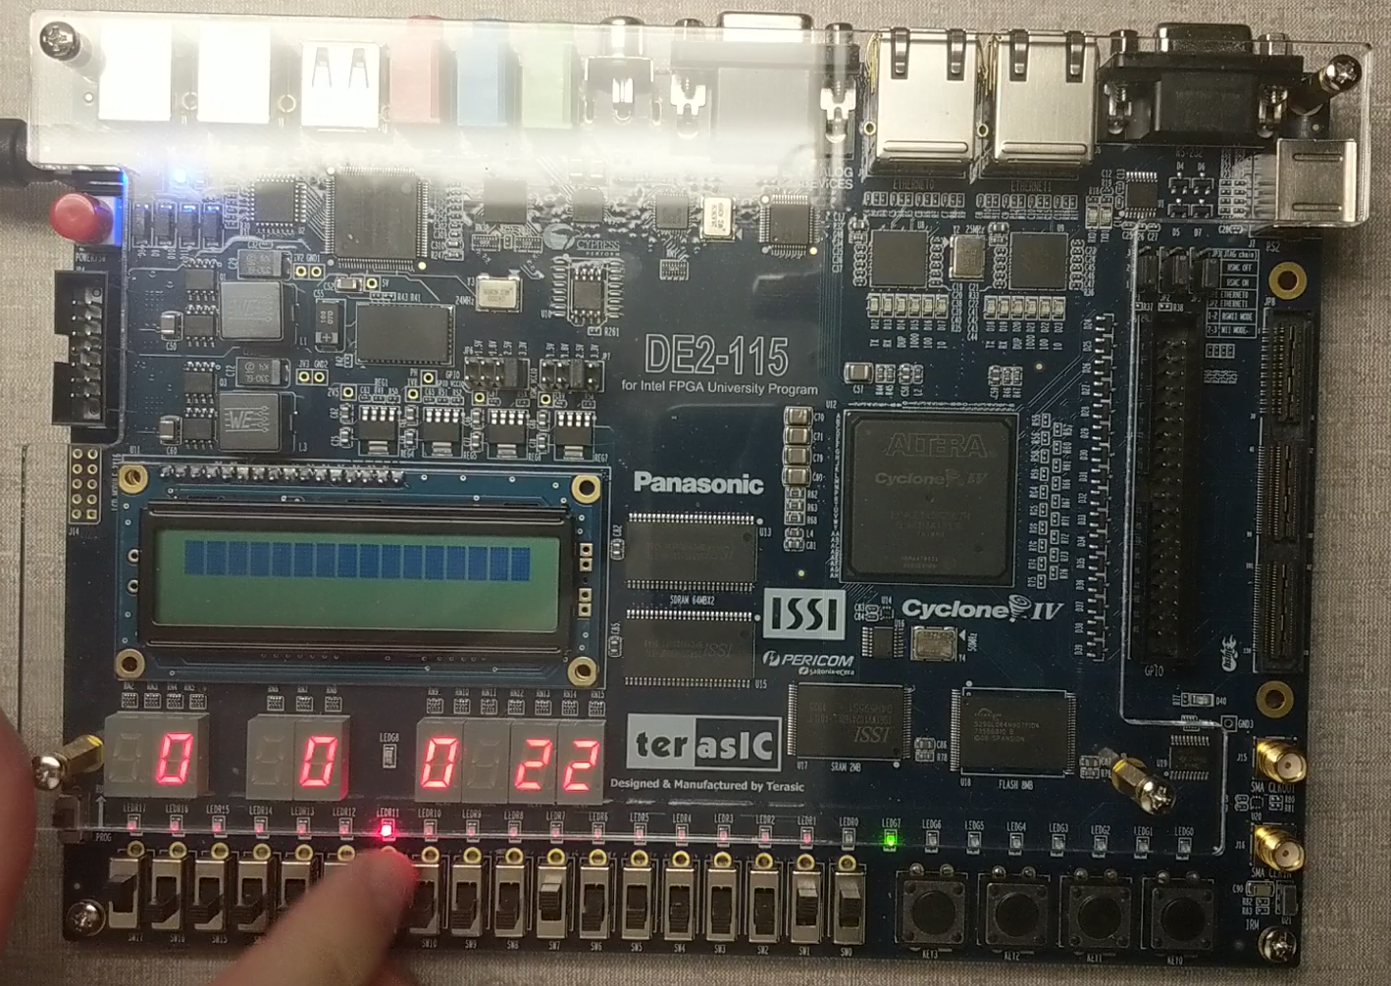

Figure 16: The system is in the SET state. The player is entering their desired time limit into the 2-digit timer.

Pressing the access control button again allows the player to enter their own time limit into the board. Changing the switch values immediately displays the change onto the two digit displays.

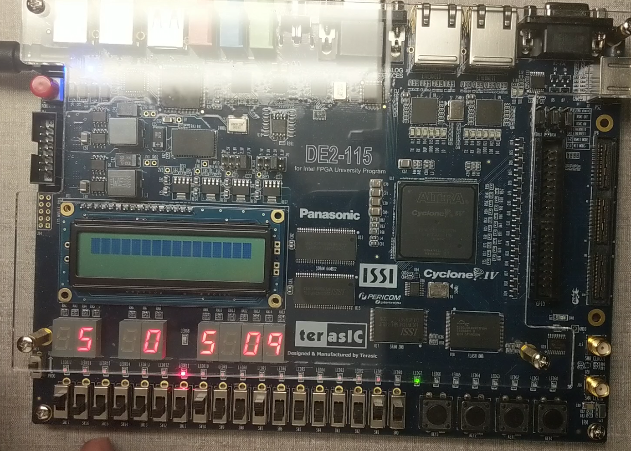

Figure 17: The timer is counting down, and the random number generator was given the signal to generate a new number.

Pressing the access control button again begins the countdown. Pressing the random number generator button generates a 5 in this case. The player must now find the correct number to enter to add to 15.

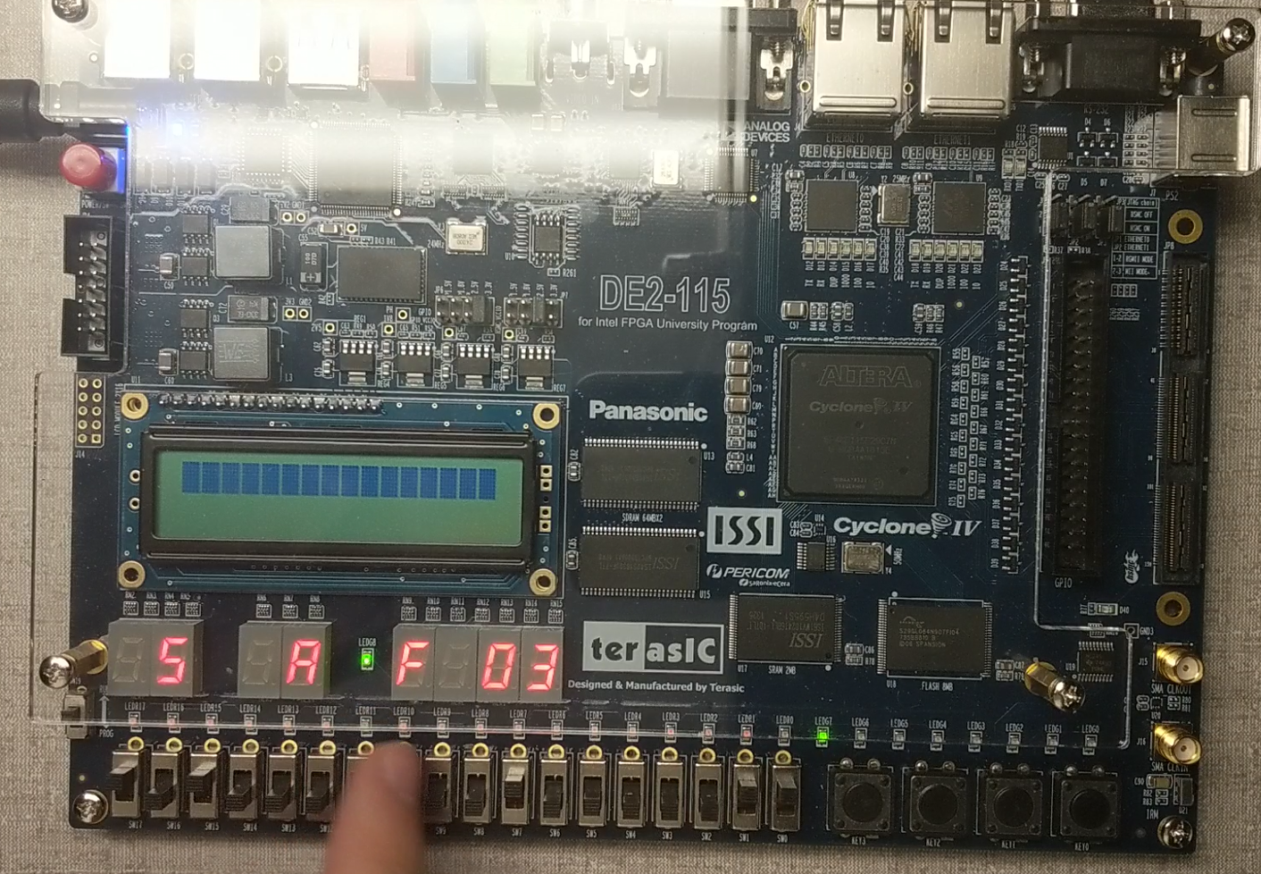

Figure 18: Player enters the correct number into the board within the round.

Here, the player enters the right number before the time limit is reached. The red LED that was on the left is now off and the nearby green LED is on, indicating a correct match. The player can generate another random number and try to match it again if there is enough time to do so.

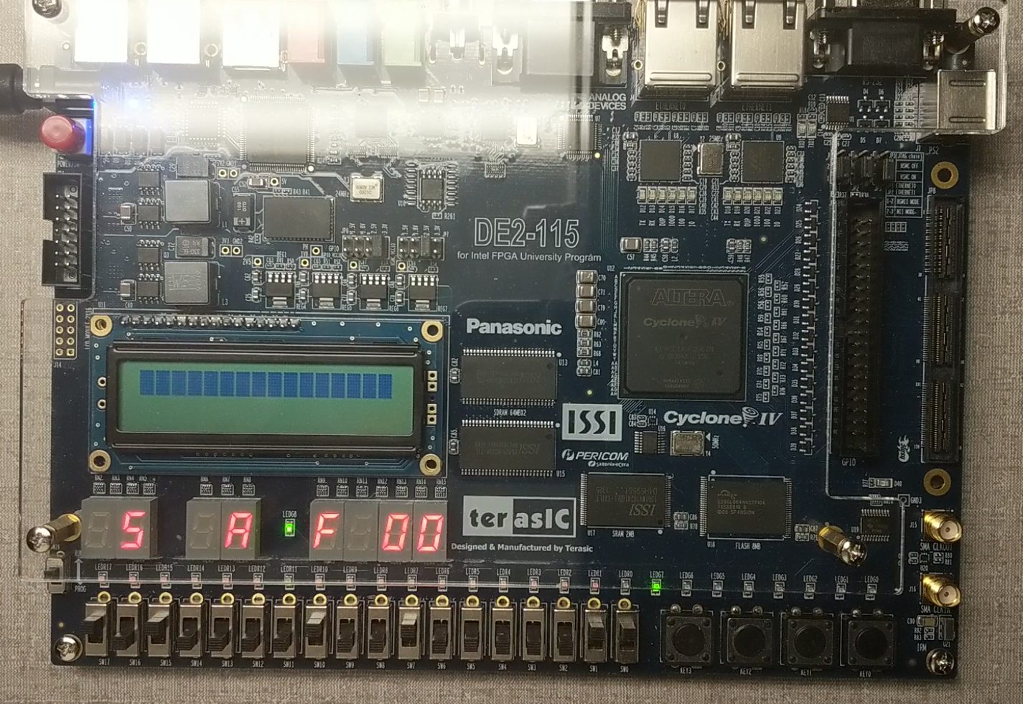

Figure 19: Time has run out and the round ends.

The timer runs out, and the player is now unable to change either the random number generator or their own register. The system is in the same functional state now as it was in Figure 16.

# **5.** Conclusion

The binary math game can be played by one person by using a random number generator as an opponent. The game allows the player to set their own time limit and attempt to match as many numbers as possible before time runs out. The game can be played for multiple successive rounds and is able to be reset to its initial values if needed.

# **5.** References

* [1] DE2-115 User Manual. (2013). [ebook] Terasic. Available at: <https://www.intel.com/content/dam/altera-www/global/en_US/portal/dsn/42/doc-us-dsnbk-42-1404062209-de2-115-user-manual.pdf>.

# **I.** Appendix

Attached below is the Verilog code that was flashed onto the FPGA. Module Lab2_BUCUR_S is the top-level module.

module bshaper(

    CLK, RST,

    b_in, b_out

    );

    input b_in, CLK, RST;

    output b_out;

    reg b_out;

    reg [1:0] currentstate, nextstate;

    parameter Init = 2'b00, Edge = 2'b01, Wait = 2'b10;

    always @ (posedge CLK) begin

        if(RST == 1'b0)

        begin

            currentstate <= Init;

        end

        else begin

            currentstate <= nextstate;

        end

    end

    always @ (currentstate, b_in) begin

        case (currentstate)

            Init: begin

                b_out <= 1'b0;

                if(b_in == 1'b1)

                begin

                    nextstate <= Init;

                end

                else begin

                    nextstate <= Edge;

                end

            end

            Edge: begin

                b_out <= 1'b1;

                nextstate <= Wait;

            end

            Wait: begin

                b_out <= 1'b0;

                if(b_in == 1'b1)

                begin

                    nextstate <= Init;

                end

                else begin

                    nextstate <= Wait;

                end

            end

            default: begin

                nextstate <= Init;

            end

        endcase

    end

endmodule

module loadreg(

    CLK, RST,

    data_in, sig_load,

    data_out

    );

    input CLK, RST, sig_load;

    input [3:0] data_in;

    output [3:0] data_out;

    reg [3:0] data_out;

    reg loadreg_state;

    parameter Store = 1'b0, Load = 1'b1;

    always @ (posedge CLK) begin

        if (RST == 0)

        begin

            loadreg_state <= Store;

            data_out <= 4'b0000;

        end

        else begin case (loadreg_state)

                Store: begin

                    if(sig_load == 1'b1)

                    begin

                        loadreg_state <= Load;

                        data_out <= data_in;

                    end

                end

                Load: begin

                    if(sig_load == 1'b0)

                    begin

                        loadreg_state <= Store;

                    end

                    if(sig_load == 1'b1)

                    begin

                        loadreg_state <= Load;

                        data_out <= data_in;

                    end

                end

                default: begin loadreg_state <= Store; end

            endcase

        end

    end

endmodule

// ECE5440

// Author: Stefan Bucur 3153

// access.v

// Description: Controls access to the game's I/O through a login system.

// Key: 3153

// Moore One-Procedure FSM

module access (

    //inputs

    CLK, RST,

    loadreg_1_in, loadreg_R_in,

    pword, pword_enter,

    timeout,

    rom_q,

    //outputs

    enable, reconf,

    loadreg_1_out, loadreg_R_out,

    pass_red, pass_green,

    //currentstate,

    addr,

    //DEBUG

    //pass_OK

    //END DEBUG

    );

    input RST, CLK, timeout;

    // input accept buttons for the two load registers

    input loadreg_1_in, loadreg_R_in;

    // user inputs 4-bit password digit

    input [3:0] pword;

    input pword_enter;

    // signals to wire out to player loadreg modules + digit timer reconf

    output enable, reconf;

    output loadreg_1_out, loadreg_R_out;

    //LED inficator of login pass/fail

    output pass_red, pass_green;

    // variables for communicating with the ROM module

    input [3:0] rom_q;

    output [1:0] addr;

    reg [1:0] addr;

    reg enable, reconf;

    reg loadreg_1_out, loadreg_R_out;

    reg pass_red, pass_green;

    //////////////////////////////////////////////DEBUG, comment out when not testbenching

    //output pass_OK;

    // display current state for simulation and debugging pruposes

    // currentstate will not be wired to any modules or I/O

    //output [3:0] currentstate;

    //////////////////////////////////////////////END DEBUG

    // FSM regs, parameters and states

    reg [3:0] currentstate; // enumerated state of the FSM

    reg pass_OK; // flag that tells if the current sequence is incorrect

    reg [3:0] pword_current; // internal variable recording player input

    reg [3:0] pword_rom; // internal variable recording ROM output

    // enumerated state values

    parameter   Init = 4'b0000, Next = 4'b0001, W1 = 4'b0010, W2 = 4'b0011,

                Get = 4'b0100, Equ = 4'b0101, Eval = 4'b0110, Pass = 4'b0111,

                OK = 4'b1000, SET = 4'b1001, PLAY = 4'b1010;

    // FSM

    // Key is retrieved from a ROM module that stores each digit as a 4-bit word

    // pass_OK acts as a flag detecting if input sequence has matched so far (default value 1)

    always @ (posedge CLK) begin

        // If RST triggered, switch case is ignored and FSM is forced to Init

        if (RST == 1'b0) begin

            addr <= 2'b00;

            pass_OK <= 1'b1;

            pass_red <= 1'b1;

            pass_green <= 1'b0;

            loadreg_1_out <= 1'b0;

            loadreg_R_out <= 1'b1;  // loadreg_R must be inverted because a 0 enables the RNG

            enable <= 1'b0;

            reconf <= 1'b0;

            currentstate <= Init;

        end

        else begin case (currentstate)

                Init: begin

                    addr <= 2'b00;

                    pass_OK <= 1'b1;

                    pass_red <= 1'b1;

                    pass_green <= 1'b0;

                    loadreg_1_out <= 1'b0;

                    loadreg_R_out <= 1'b1;

                    enable <= 1'b0;

                    reconf <= 1'b0;

                    currentstate <= Next;

                end

                Next: begin

                    //definition

                    pass_red <= 1'b1;

                    pass_green <= 1'b0;

                    loadreg_1_out <= 1'b0;

                    loadreg_R_out <= 1'b1;

                    enable <= 1'b0;

                    reconf <= 1'b0;

                    //transition

                    if(pword_enter == 1'b0)

                    begin

                        currentstate <= Next;

                    end

                    else begin

                        pword_current <= pword;

                        currentstate <= W1;

                    end

                end

                // wait two cycles for the ROM module to retrieve the data

                W1: begin

                    //definition

                    pass_red <= 1'b1;

                    pass_green <= 1'b0;

                    loadreg_1_out <= 1'b0;

                    loadreg_R_out <= 1'b1;

                    enable <= 1'b0;

                    reconf <= 1'b0;

                    //transition

                    currentstate <= W2;

                end

                W2: begin

                    //definition

                    pass_red <= 1'b1;

                    pass_green <= 1'b0;

                    loadreg_1_out <= 1'b0;

                    loadreg_R_out <= 1'b1;

                    enable <= 1'b0;

                    reconf <= 1'b0;

                    //transition

                    currentstate <= Get;

                end

                // ROM should have fetched the data by now, record the output from the memory module

                Get: begin

                    //definition

                    pass_red <= 1'b1;

                    pass_green <= 1'b0;

                    loadreg_1_out <= 1'b0;

                    loadreg_R_out <= 1'b1;

                    enable <= 1'b0;

                    reconf <= 1'b0;

                    //transition

                    pword_rom <= rom_q;

                    currentstate <= Eval;

                end

                // flag if the player input does not match what ROM returns

                Eval: begin

                    //definition

                    pass_red <= 1'b1;

                    pass_green <= 1'b0;

                    loadreg_1_out <= 1'b0;

                    loadreg_R_out <= 1'b1;

                    enable <= 1'b0;

                    reconf <= 1'b0;

                    //transition

                    if(pword_current != pword_rom) begin

                        pass_OK <= 1'b0;

                    end

                    currentstate <= Pass;

                end

                // if the sequence matched, goto game

                    // if not, reset and restart

                // if the sequence isn't finished, goto next address and loop back

                Pass: begin

                    //definition

                    pass_red <= 1'b1;

                    pass_green <= 1'b0;

                    loadreg_1_out <= 1'b0;

                    loadreg_R_out <= 1'b1;

                    enable <= 1'b0;

                    reconf <= 1'b0;

                    //transition

                    if(addr >= 2'b11) begin

                        if(pass_OK == 1'b1) begin

                            currentstate <= OK;

                        end

                        else begin

                            currentstate <= Init;

                        end

                    end

                    else begin

                        addr <= addr + 2'b01;

                        currentstate <= Next;

                    end

                end

                // game loop

                OK: begin

                    if(pword_enter == 1'b0)

                    begin

                        pass_red <= 1'b0;

                        pass_green <= 1'b1;

                        loadreg_1_out <= 1'b0;

                        loadreg_R_out <= 1'b1;

                        enable <= 1'b0;

                        reconf <= 1'b0;

                        currentstate <= OK;

                    end

                    else begin

                        currentstate <= SET;

                    end

                end

                SET: begin

                    if(pword_enter == 1'b0)

                    begin

                        pass_red <= 1'b0;

                        pass_green <= 1'b1;

                        loadreg_1_out <= 1'b0;

                        loadreg_R_out <= 1'b1;

                        enable <= 1'b0;

                        reconf <= 1'b1;

                        currentstate <= SET;

                    end

                    else begin

                        currentstate <= PLAY;

                    end

                end

                PLAY: begin

                    if(timeout == 1'b0)

                    begin

                        pass_red <= 1'b0;

                        pass_green <= 1'b1;

                        loadreg_1_out <= loadreg_1_in;

                        loadreg_R_out <= loadreg_R_in;

                        enable <= 1'b1;

                        reconf <= 1'b0;

                        currentstate <= PLAY;

                    end

                    else begin

                        if(timeout == 1'b1)

                        begin

                            currentstate <= OK;

                        end

                    end

                end

                default: begin currentstate <= Init; end

            endcase

        end

    end

endmodule

// megafunction wizard: %ROM: 1-PORT%

// GENERATION: STANDARD

// VERSION: WM1.0

// MODULE: altsyncram

// ============================================================

// File Name: ROM_BUCUR_S.v

// Megafunction Name(s):

//          altsyncram

//

// Simulation Library Files(s):

//          altera_mf

// ============================================================

// ************************************************************

// THIS IS A WIZARD-GENERATED FILE. DO NOT EDIT THIS FILE!

//

// 18.1.0 Build 625 09/12/2018 SJ Lite Edition

// ************************************************************

//Copyright (C) 2018  Intel Corporation. All rights reserved.

//Your use of Intel Corporation's design tools, logic functions

//and other software and tools, and its AMPP partner logic

//functions, and any output files from any of the foregoing

//(including device programming or simulation files), and any

//associated documentation or information are expressly subject

//to the terms and conditions of the Intel Program License

//Subscription Agreement, the Intel Quartus Prime License Agreement,

//the Intel FPGA IP License Agreement, or other applicable license

//agreement, including, without limitation, that your use is for

//the sole purpose of programming logic devices manufactured by

//Intel and sold by Intel or its authorized distributors.  Please

//refer to the applicable agreement for further details.

// synopsys translate_off

`timescale 1 ps / 1 ps

// synopsys translate_on

module ROM_BUCUR_S (

    address,

    clock,

    q);

    input   [1:0]  address;

    input     clock;

    output  [3:0]  q;

`ifndef ALTERA_RESERVED_QIS

// synopsys translate_off

`endif

    tri1      clock;

`ifndef ALTERA_RESERVED_QIS

// synopsys translate_on

`endif

    wire [3:0] sub_wire0;

    wire [3:0] q = sub_wire0[3:0];

    altsyncram  altsyncram_component (

                .address_a (address),

                .clock0 (clock),

                .q_a (sub_wire0),

                .aclr0 (1'b0),

                .aclr1 (1'b0),

                .address_b (1'b1),

                .addressstall_a (1'b0),

                .addressstall_b (1'b0),

                .byteena_a (1'b1),

                .byteena_b (1'b1),

                .clock1 (1'b1),

                .clocken0 (1'b1),

                .clocken1 (1'b1),

                .clocken2 (1'b1),

                .clocken3 (1'b1),

                .data_a ({4{1'b1}}),

                .data_b (1'b1),

                .eccstatus (),

                .q_b (),

                .rden_a (1'b1),

                .rden_b (1'b1),

                .wren_a (1'b0),

                .wren_b (1'b0));

    defparam

        altsyncram_component.address_aclr_a = "NONE",

        altsyncram_component.clock_enable_input_a = "BYPASS",

        altsyncram_component.clock_enable_output_a = "BYPASS",

        altsyncram_component.init_file = "ROM_BUCUR_S.mif",

        altsyncram_component.intended_device_family = "Cyclone IV E",

        altsyncram_component.lpm_hint = "ENABLE_RUNTIME_MOD=NO",

        altsyncram_component.lpm_type = "altsyncram",

        altsyncram_component.numwords_a = 4,

        altsyncram_component.operation_mode = "ROM",

        altsyncram_component.outdata_aclr_a = "NONE",

        altsyncram_component.outdata_reg_a = "CLOCK0",

        altsyncram_component.widthad_a = 2,

        altsyncram_component.width_a = 4,

        altsyncram_component.width_byteena_a = 1;

endmodule

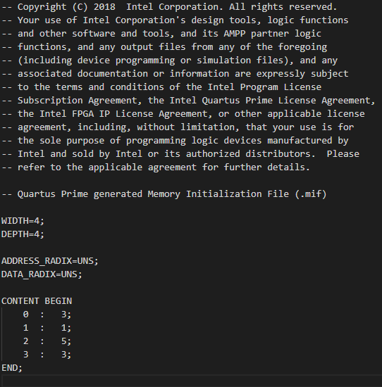

module adder (in1, in2, sum);

    input [3:0] in1, in2;

    output [3:0] sum;

    reg [3:0] sum;

    always @ (in1, in2)

        begin

            sum = in1 + in2;

        end

endmodule

module decoder7 (hex, seg7);

    input [3:0] hex;

    output [6:0] seg7;

    reg [6:0] seg7;

    always @ (hex)

    begin

        case(hex)

            4'b0000: begin seg7 = 7'b1000000; end

            4'b0001: begin seg7 = 7'b1111001; end

            4'b0010: begin seg7 = 7'b0100100; end

            4'b0011: begin seg7 = 7'b0110000; end

            4'b0100: begin seg7 = 7'b0011001; end

            4'b0101: begin seg7 = 7'b0010010; end

            4'b0110: begin seg7 = 7'b0000010; end

            4'b0111: begin seg7 = 7'b1111000; end

            4'b1000: begin seg7 = 7'b0000000; end

            4'b1001: begin seg7 = 7'b0011000; end

            4'b1010: begin seg7 = 7'b0001000; end

            4'b1011: begin seg7 = 7'b0000011; end

            4'b1100: begin seg7 = 7'b1000110; end

            4'b1101: begin seg7 = 7'b0100001; end

            4'b1110: begin seg7 = 7'b0000110; end

            4'b1111: begin seg7 = 7'b0001110; end

        endcase

    end

endmodule

module check(

    sum,

    status);

    input [3:0] sum;

    output [1:0] status;

    reg [1:0] status;

    always @(sum)

    begin

        if( sum == 4'b1111 )

        begin

            status = 2'b01;

        end

        else

        begin

            status = 2'b10;

        end

    end

endmodule

// ECE5440

// Author: Stefan Bucur 3153

// Module: cnt1000

// Description: counter for the secTimer module; receives a pulse every 1ms

module cnt1000(rst, cnt_up, pulse_sec);

    input rst, cnt_up;

    output pulse_sec;

    reg pulse_sec;

    reg [9:0] cnt;

    always @ (posedge cnt_up) begin

        if(rst == 1'b0)

        begin

            cnt <= 0;

            pulse_sec <= 0;

        end

        else begin

            if(cnt >= 1000)

            begin

                cnt <= 0;

                pulse_sec <= 1;

            end

            else begin

                pulse_sec <= 0;

                cnt <= cnt + 10'b1;

            end

        end

    end

endmodule

// ECE5440

// Author: Stefan Bucur 3153

// Module: timer_1ms

// Description: Sends a short pulse every 1millisecond.

//      timer assumed to be connected to a 50MHz oscillator

module timer_1ms(clk, rst, en, pulse_1ms);

    input clk, rst, en;

    output pulse_1ms;

    reg pulse_1ms;

    reg [31:0] cnt;

    always @ (posedge clk) begin

        if(rst == 1'b0)

        begin

            cnt <= 0;

            pulse_1ms <= 0;

        end

        else begin

            if(en == 1'b1)

            begin

                if(cnt >= 50000)

                begin

                    cnt <= 0;

                    pulse_1ms <= 1;

                end

                else begin

                    cnt <= cnt + 1;

                    pulse_1ms <= 0;

                end

            end

            else begin

                pulse_1ms <= 0;

            end

        end

    end

endmodule

// ECE5440

// Author: Stefan Bucur 3153

// Module: digitTimer

// Description: scalable digit timer for the FPGA game.

//  timer talks to adjacent digits to determine next value

module digitTimer (

    reconf, count_default,

    borrow_up, borrow_dn,

    noborrow_up, noborrow_dn,

    count

    );

    input borrow_dn, noborrow_up, reconf;

    input [3:0] count_default;

    output borrow_up, noborrow_dn;

    output [3:0] count;

    reg borrow_up, noborrow_dn;

    reg [3:0] count;

    always @ (posedge borrow_dn, posedge reconf) begin

        if (reconf == 1'b1)

        begin

            if(count_default > 9)

            begin

                count <= 4'b1001;

                noborrow_dn <= 1'b0;

            end

            else begin

                count <= count_default;

                if(count_default == 0)

                begin

                    noborrow_dn <= 1'b1;

                end

                else begin

                    noborrow_dn <= 1'b0;

                end

            end

            borrow_up <= 1'b1;

        end

        else begin

            if (count == 4'b0000)

            begin

                if (noborrow_up == 1'b0)

                begin

                    // back up to 9, signal to slave digit

                    count <= 4'b1001;

                    borrow_up <= 1'b1;

                    noborrow_dn <= 1'b0;

                end

                else begin

                    borrow_up <= 1'b1;

                    noborrow_dn <= 1'b1;

                end

            end

            else begin

                // no edge cases here, subtract when asked by child timer (borrow_dn pulse)

                count <= count - 4'b0001;

                borrow_up <= 1'b0;

                noborrow_dn <= 1'b0;

            end

        end

    end

endmodule

// ECE5440

// Author: Stefan Bucur 3153

// Module: digitTimer_2

module digitTimer_2(

    reconf, count_default1, count_default2,

    borrow_up, borrow_dn,

    noborrow_up, done,

    count_tens, count_ones

    );

    input reconf, borrow_dn, noborrow_up;

    input [3:0] count_default1, count_default2;

    //connect the two digitTimers together

    wire borrow_mid, noborrow_mid;

    wire noborrow_dn;

    output borrow_up;

    output done;

    output [3:0] count_tens, count_ones;

    reg done;

    digitTimer tens(

        reconf, count_default1,

        borrow_up, borrow_mid,

        noborrow_up, noborrow_mid,

        count_tens

    );

    digitTimer ones(

        reconf, count_default2,

        borrow_mid, borrow_dn,

        noborrow_mid, noborrow_dn,

        count_ones

    );

    always @ (count_tens, count_ones, reconf) begin

        if(count_tens == 4'b0000 && count_ones == 4'b0000 && reconf == 1'b0)

        begin

            done <= 1'b1;

        end

        else begin

            done <= 1'b0;

        end

    end

endmodule

// ECE5440

// Author: Stefan Bucur 3153

// Module: secTimer

// Description: 1-second timer for the FPGA. Timer is assumed to be connected to a 50MHz oscillator.

module secTimer(clk, rst, en, pulse_1s);

    input clk, rst, en;

    output pulse_1s;

    wire pulse_1ms;

    cnt1000 counter (rst, pulse_1ms, pulse_1s);

    timer_1ms timer (clk, rst, en, pulse_1ms);

endmodule

// ECE5440

// Author: Stefan Bucur 3153

// Module: cnt4

// Description: 4-bit counter updating on each clock cycle.

module cnt4 (

    //inputs

    CLK, RST, sig_in,

    //outputs

    count

    );

    input CLK, RST;

    input sig_in;

    output [3:0] count;

    reg [3:0] count;

    always @ (posedge CLK) begin

        if(RST == 1'b0)

        begin

            count <= 4'b0000;

        end

        else begin

            if(sig_in == 1'b1)

            begin

                count <= count + 4'b1;

            end

        end

    end

endmodule

// ECE5440

// Author: Stefan Bucur 3153

// Module: trng

// Description: True random 4-bit number generator.

module trng (

    //inputs

    CLK, RST,

    button_trng,

    //outputs

    rand_num

    );

    input CLK, RST;

    input button_trng;

    wire counter_in_internal;

    output [3:0] rand_num;

    assign counter_in_internal = ~button_trng;

    cnt4 counter(CLK, RST, counter_in_internal, rand_num);

endmodule

// ECE5440

// Author: Stefan Bucur 3153

// Lab3_BUCUR_S.v

// Description: Top-level module to be flashed onto an FPGA.

// Key: 3153

module Lab3_BUCUR_S(

    // inputs

    CLOCK, RESET,

    player_data, acc_data,

    time_def_tens, time_def_ones,

    bot_sel, player_sel, acc_sel,

    // outputs

    bot_digit, player_digit, sum_digit,

    sum_status, pass_r, pass_g,

    ten_digit, one_digit, //acc_state,

    GND

    );

    input CLOCK, RESET;

    input [3:0] player_data, acc_data;

    input [3:0] time_def_tens, time_def_ones;

    input bot_sel, player_sel, acc_sel;

    output [6:0] bot_digit, player_digit, sum_digit, ten_digit, one_digit;

    output [1:0] sum_status;

    output pass_r, pass_g, GND;

    wire [2:0] acc_state;

    wire bot_bpress, player_bpress, acc_bpress;

    wire bot_acc, player_acc;

    wire [3:0] bot_w, player_w, add_w;

    wire [3:0] ten_w, one_w;

    wire enable, timeout, reconf, time_pulse;

    decoder7 bot_dec(bot_w, bot_digit);

    decoder7 player_dec(player_w, player_digit);

    decoder7 sum_dec(add_w, sum_digit);

    decoder7 ten_dec(ten_w, ten_digit);

    decoder7 one_dec(one_w, one_digit);

    adder player_sum(bot_w, player_w, add_w);

    check sum_result(add_w, sum_status);

    trng pbot(CLOCK, RESET, bot_acc, bot_w);

    loadreg player_num(CLOCK, RESET, player_data, player_acc, player_w);

    access acc_ctl(CLOCK, RESET,

                   player_bpress, bot_sel,

                   acc_data, acc_bpress,

                   timeout,

                   enable, reconf,

                   player_acc, bot_acc,

                   pass_r, pass_g, acc_state

    );

    bshaper player_button(CLOCK, RESET, player_sel, player_bpress);

    bshaper acc_button(CLOCK, RESET, acc_sel, acc_bpress);

    digitTimer_2 timer (reconf, time_def_tens, time_def_ones,

                        GND, time_pulse,

                        GND, timeout,

                        ten_w, one_w

    );

    secTimer timer_clk (CLOCK, RESET, enable, time_pulse);

endmodule